1.
Open your own laptop or desktop (or use an online PC hardware simulator if you don't have access to a real system) and identify the GPU model installed. Write down the GPU's brand, model number, and whether it is integrated or dedicated.

GPU identification
Use your computer’s system information to find the GPU model. Record it in this format:

Item Details
GPU brand [e.g., NVIDIA / AMD / Intel]
GPU model number [e.g., NVIDIA GeForce RTX 4060]
Type [Integrated / Dedicated]

How to check on Windows: Press Ctrl + Shift + Esc → Performance → GPU. The GPU name will be displayed there.

2.
Take a clear photo or screenshot of the cooling system (fan, heatsink, or liquid cooling setup) inside your PC or from a PC hardware simulator. Label the main cooling components and briefly describe their function.

Cooling system
Take a clear photo/screenshot of the inside of your PC and label:
- GPU fan — spins to move air across the heatsink.
- Heatsink — absorbs heat from the GPU and spreads it across its fins.
- Heat pipes — transfer heat away from the GPU toward the heatsink.
- GPU shroud — directs airflow through the cooling assembly.
- Case fans — bring cool air into the case and exhaust warm air.
If your system uses liquid cooling, also label the water block, pump, radiator, and tubing.

3.
Create a comparison table listing at least 3 differences between air cooling and liquid cooling systems for GPUs, including factors like cost, efficiency, and maintenance.

Air cooling vs. liquid cooling

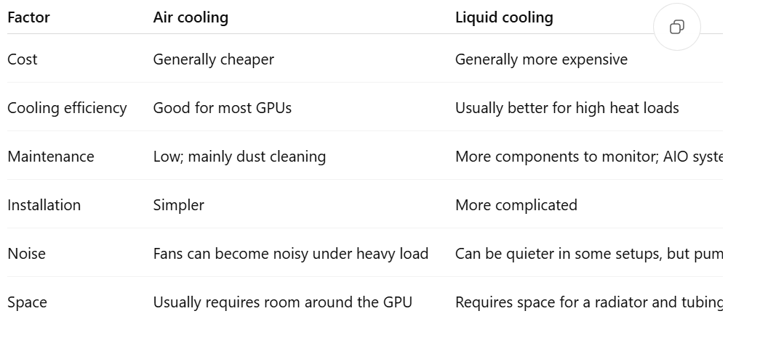

4.
Imagine you are building a gaming PC for streaming IPL matches and playing graphics-heavy games. Choose between air cooling and liquid cooling for your GPU, and justify your choice in 3-4 sentences based on your research.

Choice for a gaming and IPL-streaming PC

I would choose air cooling for the GPU. A good GPU air cooler provides sufficient cooling for graphics-heavy gaming while being simpler and less expensive than a liquid-cooling setup. Streaming IPL matches does not normally require liquid cooling because video streaming places much less thermal demand on the GPU than demanding games. Liquid cooling would be worth considering mainly for an exceptionally powerful GPU, overclocking, or a build where maximum thermal performance is a priority.

